Passive HD TVI/CVI/AHD Video Balun

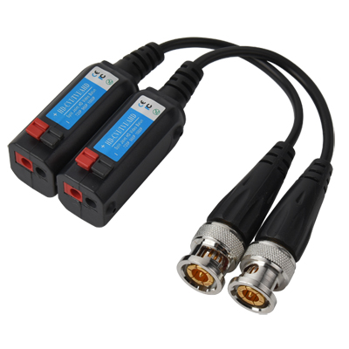
Features:
- Import Original Chips
- Passive HD Video Balun
- Max.300m for 720P Video
- Max.200m for 1080P Video
- Max.150m for 3MP Video
- Max.100m for 4MP Video
- Real Time Transmission
- Support HD-TVI/CVI/AHD Video Format High-Quality Image
- Exceptional Interference Rejection
- Wave Filter Design, Anti-Static Design, Lightning Protection
- Compact Size and Easy Installation
- Cost-Effective

Specifications:
Model | BTP-01
Product Name | Passive HD Video Balun
Video
Compatible Format | TVI/CVI/AHD
Resolution | 720P/960P/1080P/3MP/4MP
Transmission Signal | 1 Channel
Transmission Distance | 720P:Max.300m /1080P:Max.200m/3MP:Max.150m /4MP:Max.100m
Operating Frequency | DC to 60MHz
Common-Mode | 15KHz to 42MHz 60 dB typ
Attenuation | 1.5dB typical
Impedance | Coax, Male BNC 75Ω unbalanced
 | UTP, Push Terminal 100Ω balanced
MTBF | >30000H
Wire Type
Network Wiring | One Unshield Twisted Pair(for each video signal)24-16AWG(0.5-1.31mm)
Network Wiring | One Pair Unshielded Twisted (for each video signal)24-16AWG(0.5-1.31mm)
Category Type | UTP CAT 5/5E/6 (R＜10Ω/100M)
Impedance | 100±20ohms
DC Loop Resistance | 52 ohms per 1000ft(18 ohms per 100m)
Differential Capacitance | 19 pF/ft max (62 pF/m max)
Power
Power Required | No
Protection
Surge Protection | 1KV（10/700µs）
ESD | 4KV
Anti-Interference | >60dB
Connector
Video Input / Output | Male BNC / Push Terminal
Mechanical
Housing | ABS engineering plastic
Body Color | Black
Dimensions | 41 x 20 x 20mm with130mm cable
Gross Weight | 53g/pair(2pcs in a blister card)
Environment
Operating Temperature | -20℃-70℃
Relative Humidity | 0-95%(non-condensing)
Storage Temperature | -40℃-80℃

